HealthCare Schema Design

- The Healthcare includes following requirements
- Patients may have multiple Appointments.
- Doctor may have multiple Appointments.
- Doctor belongs to one department.
- Appointments may include multiple Medical Services.
- An appointment generates one invoice.
- An invoice can include multiple Services.
- Payments can be made in multiple instalments.
- Main Entities
- Department
- Patient
- Doctor
- Appointment
- Medical Service
- Invoice
- Payment
- Crow Feet Diagram
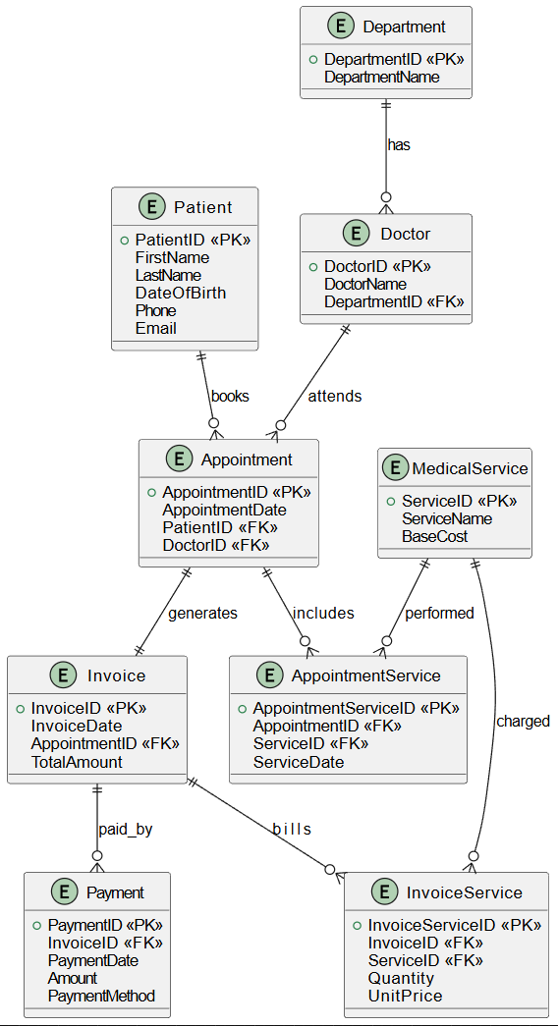

- Relationship between entities

